**P2-/M1 an explanation of the characteristics of digital and analogue control systems.**

**Scenario**

In this assignment, I will be explaining the definition of digital signals and analogue signals. I will be giving the advantage and disadvantage for both signals. In addition, I will be comparing both of the signals.

**Analogue signals**

An analogue signal is any continuous signal which contains time-varying quantities. These analogue signals were introduced in the mid-1990s. An example of analogue signals are speakers. This is a good example as you can increase the sound slowly and constantly. An example that analogue signals were used in the 19th century were old radios. You could continuously change the signal at any time. The analogue signal could be measured by three of the following:

* Light
* Sound
* Temperature

The main advantage of using analogue signals is that they have a higher density than digital signals. They have an infinite amount of signal resolution and they differ from digital signals. Analogue signals are continuous electric signals. Analogue signals have a low cost and are portable but digital signals are not easily portable and are expensive. It can change their amplitude or frequency in response to light, sound and temperature. However, the most major disadvantage of using analogue signals is that it can create a lot of noise. Whereas, analogue signals doesn’t create as much noise as analogue signals do. Referring to Figure 1.1, it shows how analogue signals look like. It flows like a continuous wave.

[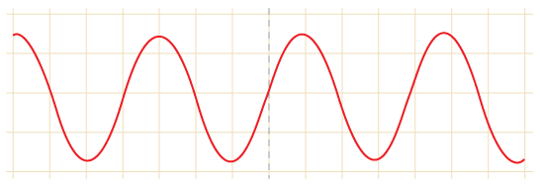](http://www.google.co.uk/url?sa=i&rct=j&q=&esrc=s&frm=1&source=images&cd=&cad=rja&uact=8&docid=6sVpW34c1psqGM&tbnid=H7IdA7nqsj8IZM:&ved=0CAYQjRw&url=http://www.bbc.co.uk/schools/gcsebitesize/design/electronics/logicrev1.shtml&ei=BygoU5TxIqPF0QW_o4DoAQ&bvm=bv.62922401,d.ZG4&psig=AFQjCNFSu-DSumdrqJdh1gNSKdF5MBr7mg&ust=1395227002801251)**Figure 1.1**

**Digital signals**

A digital signals are series of pulses that consist of two states: ON and OFF. A digital broadcast radio transmits digital signals. The waveform for digital signal switches levels from two states (0 and 1). When the digital signal is off, the number 0 represents it. When the digital signal is on, the number 1 represents it by the data. Referring to Figure 1.2, it shows us how digital signal would be data based if it would be inputted into the computer. An example of where digital signal is used is:

* PCs
* PDAs
* Mobile Phones

The main advantage of digital signals over analogue signals is that the precise signal level of the digital signal is not vital. This means that digital signals are accurate when measured. Another advantage is that it costs less electronically than analogue. Another advantage is that it carries more information per second than analogue signal. As a result, the quality is better. This is because if you increase the volume, the quality will stay the game, but analogue, it wouldn’t. However, the disadvantage of using digital signals is that it is complex, not portable and expensive.

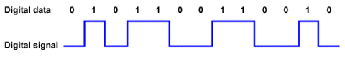**Figure 1.2**

**Comparison**

Digital signals transfer data and in the process, they do not lose the quality once reached the destination. Referring to Figure 1.3, it demonstrates the quality of both signals. Digital regenerates whereas analogue signals has a weak quality throughout the process. Digital signal can be interrupted, ON and OFF button, whereas analogue signal is a continuous signal that can travel far. It is more flexible and it can upgrade to an easier system very quickly and easily. Analogue signals are less tolerant to noise but digital signals are more tolerant to noise. **Figure 1.3**

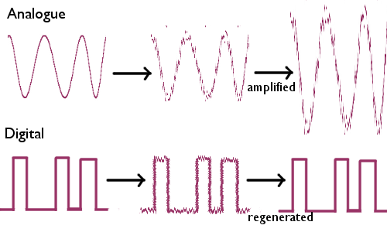

**Reference**

<http://www.technologystudent.com/elec1/anadig1.htm>

<http://www.princeton.edu/~achaney/tmve/wiki100k/docs/Analog_signal.html>

<http://www.bbc.co.uk/schools/gcsebitesize/science/ocr_gateway/home_energy/data_transmissionrev2.shtml>

<http://en.wikipedia.org/wiki/Comparison_of_analog_and_digital_recording>